Science- reversible and irreversible changes
Our science learning will support us to answer the following core questions:
-What is the difference between solids, liquids and gases.

-How can materials be separated?

-Which changes are reversable and which irreversible?

Maths
Fractions, decimals percentages
Area, Perimeter and Volume
Regular arithmetic practice
Regular times tables practice

English
Read and discuss Boy at the Back of the Class
Write a non-chronological report
Spelling – 10 new words per week

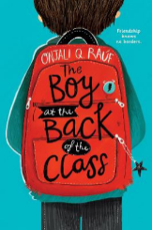

Year 6 Rowling class
Term 4 - Curriculum Map

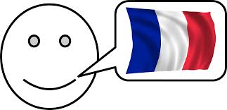
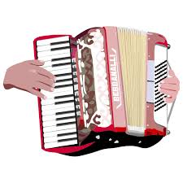
P.E (Mondays and Tuesdays)
Cricket and Dance

French
Les vêtements

PSHE – Rights and Responsibilities
We will be learning about deomocracy, money and caring for the environment.
Computing- Programming

We will be developing a programme with inputs and outputs.
D&T- Structures (design a kite)

We will be researching, designing, planning and then building structures to make a kite. We’ll then test and evaluate our kites.
Geography- Why does population change?
How does population increase over time?
What causes climate change and what can we do to reduce it?
What is migration and why do people leave their homes?
Music- Recorders
Develop and extend recorder playing skills
Explore extended recorder techniques to improvise and create group compositions
R.E –

We will be focussing on the question how significant is it for Christians to believe God intended Jesus to die?

