WELLBEING TEAM MINUTES
FRIDAY 11TH SEPTEMBER

PRESENT: Mrs Cooper, Ava, Jenny, Reggie, Delilah, Aisha, Ariela, Raheel, Beatrice, Ella, Alana, Ivy, Sarah, Jessica, Daphne,

- Mrs Cooper showed the children the new Wellbeing Hi-vis jackets and we took photos of the children wearing them and the whole team for our new display board.

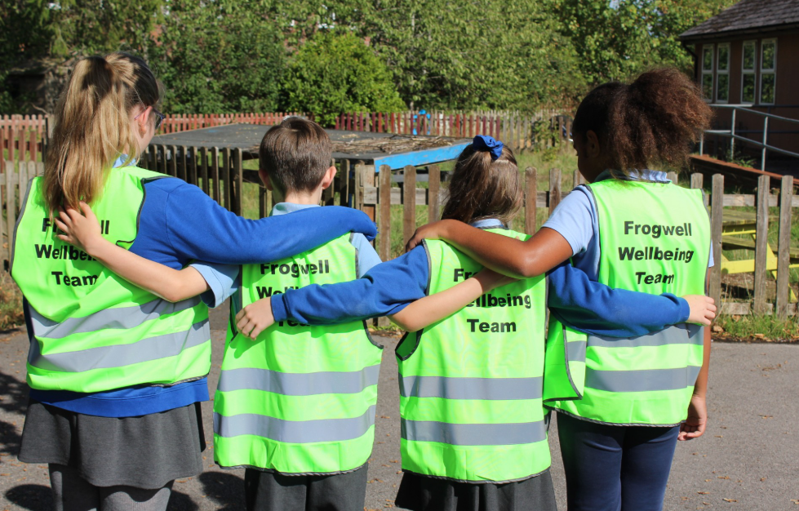

- Mrs Cooper asked the team to work in year groups to organise a rota for playtime and lunchtime so that the Wellbeing Team are present outside.

